Let’s there is only one disc in source tower-

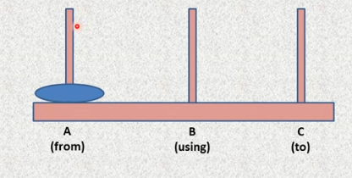

So, if we –

* **Move a disc from A to C**

Is enough.

When there is two disc-

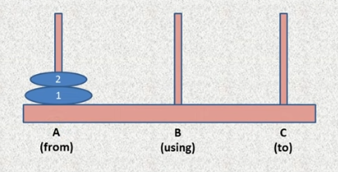

* **Move a disc from A to B using C.**
* **Move a disc from A to B**
* **Move a disc from B to C using A.**

Let’s take 3 discs in the source pole.

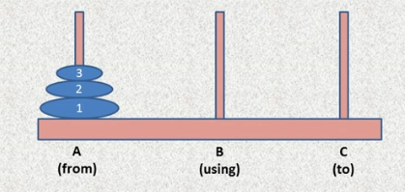

Try to divide this into (1, (2,3)) so there is total two disc now. So we can use the previous two disc solution method –

* Move a disc (here (2,3) is regarded as one disk) from A to B using C.
* Move a disc (which is 1) from A to C.
* Move a disc (again (2,3) is regarded as one disk) from B to C using A.

So here is the final recursive solution:

* **Move (n-1) disc from Source to Auxiliary using Destination.**
* **Move a disc from Source to Destination.**
* **Move (n-1) disc from Auxiliary to Destination using Source.**